**LOGISTICAL NOTE**

**6th International Forum on Long-Term Scenarios for the Clean Energy Transition**

**29-30 October 2024**

**Bonn, Germany**

This note is intended to provide useful administrative and logistical information for delegates attending IRENA’s 6th International Forum on Long-Term Scenarios for the Clean Energy Transition.

Contents

Requirements 2

Meeting Venue 2

Information for all participants 3

Miscellaneous 6

Further contact 7

# **Requirements**

**Dietary restrictions**

Kindly communicate any dietary restrictions you may have **as soon as possible**.

# 

# **Meeting Venue**

**Meeting Room:** IITC Bonn Conference Room (ground floor)

**Address:** [IRENA Innovation and Technology Center](https://www.google.com/maps/dir/irena+iitc+bonn/@50.7001632,7.1027916,13z/data=!4m8!4m7!1m0!1m5!1m1!1s0x47bee3fcf5fa4f69:0x1f59b45043f3c656!2m2!1d7.1201472!2d50.7166078), Thomas-Dehler-Haus, Willy-Brandt-Allee 20, 53113 Bonn

**Phone:** +49 228 391 79085

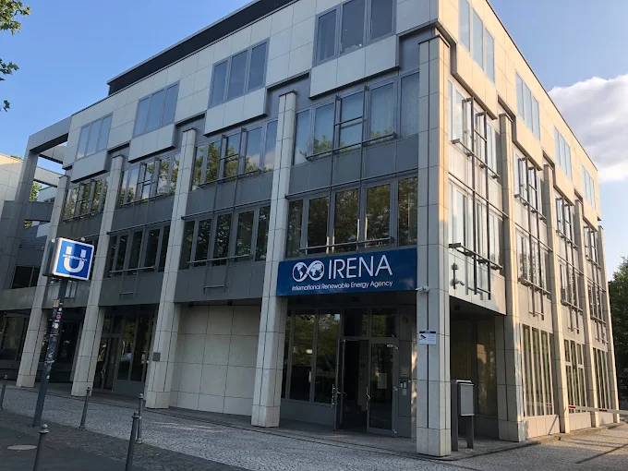

Figure 1IRENA IITC Building in Bonn, Germany

# **Information for all participants**

***Ground transportation***

**Airport transfers:**

You can book online the train or bus tickets from the airport (Cologne Bonn Airport or Frankfurt Airport) to the Maritim Hotel in Bonn using the German Deutsche Bahn (DB) website [www.bahn.com/en](http://www.bahn.com/en). You can also download the app DB Navigator on your phone for this purpose.

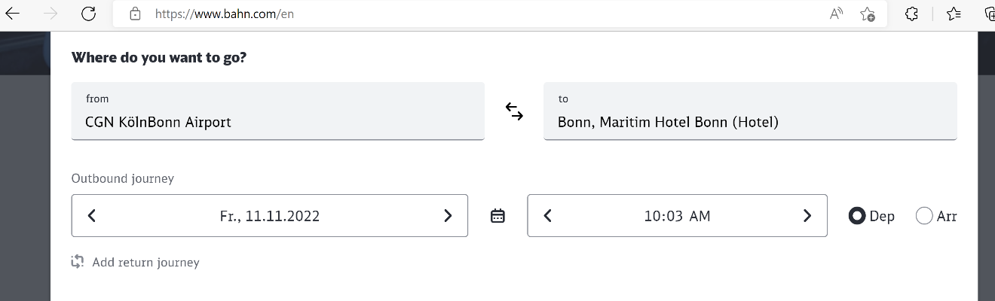

Figure 2 Screenshot of DB website for booking tickets

Alternatively, you can visit the DB Resiezentrum (travel center) at the airport, where you can buy the tickets physically. Or you can [buy the ticket using the Fahrkarten ticket machine](https://www.youtube.com/watch?v=H9tIc04dp8A&ab_channel=WanderInGermany) using cash or card. You can select the language of your choice.

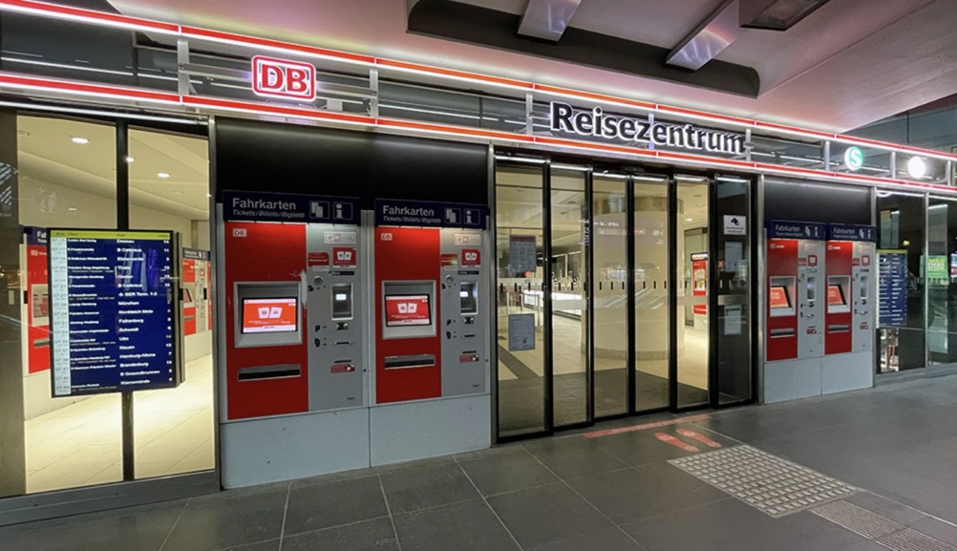

Figure 3 DB Reisezentrum (Travel center) and ticket machines

**Transportation from Bonn Central Station to IITC Offices and back to the Centre**

IRENA IITC building is located approximately 2.7 km (34 min) walking distance from the Bonn Central Train Station (Bonn HBF).

You can travel from the Bonn HBF to IITC by trams 16, 63 or 66. The IITC building is just above the **Heussallee/Museumsmeile station**. One-way ticket costs 2.8 Euros per person, which is to be borne by the participant himself/herself.

Alternatively, a weekly ticket (Wochenticket) of approximately 30 Euros for 1-b price tier (Preisstufen) can also be purchased for travelling in 1-b region within Bonn.

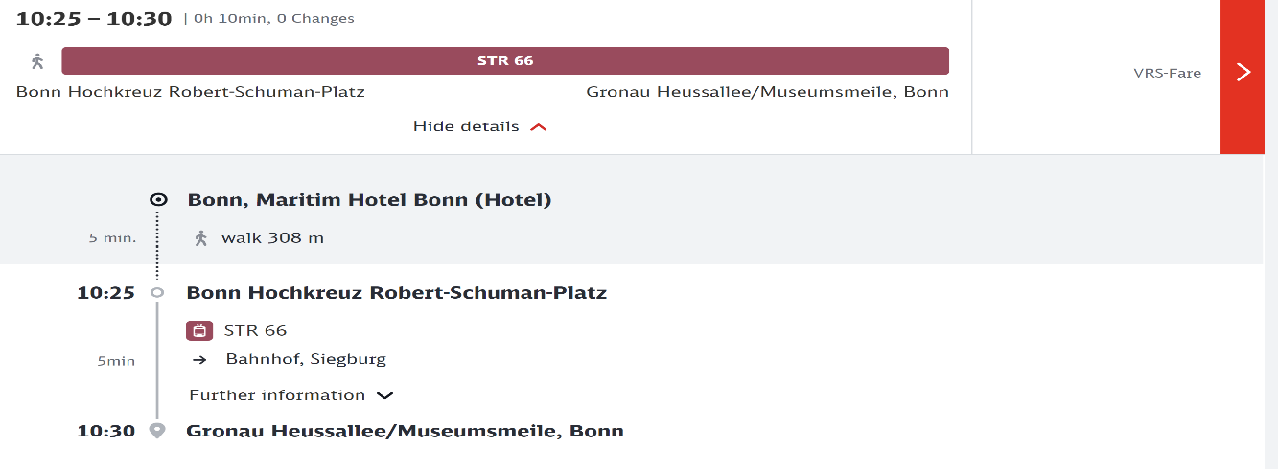

Figure 4 Screenshot of DB website for booking ticket between Maritim Hotel and IITC Bonn

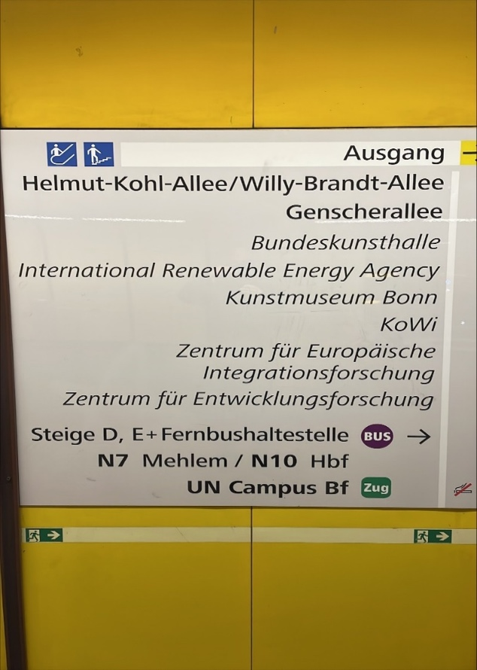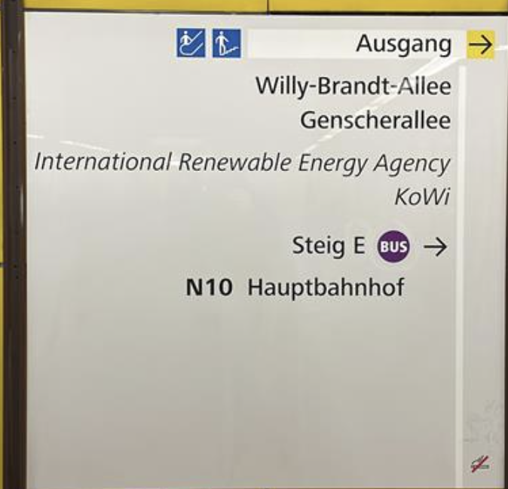

Figure 5 Exit sign to IRENA IITC office at the Heusalle/Museumsmeile tram stop

Upon arrival at Heussallee/Museumsmeile’stram stop, you will be guided with the sign above, to take the exit to your right to Bonn IRENA's office (if you are facing this sign).

**Note:**

If the ticket is purchased from the ticket machine outside of the tram, it must be stamped to get validated. Stamping machines are also present inside trams. Alternatively, if you buy the ticket from the ticket machine inside the tram or online, it is automatically validated for the journey.

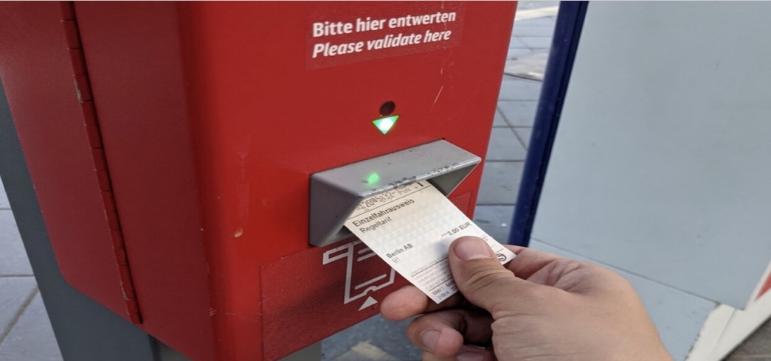

Figure 6 Ticket stamping machines can be present inside trams, or also outside in the station

**Meals and events:**

Lunch and coffee will be provided at the IRENA IITC premises on the two days of the conference, free of charge for all registered participants.

Registered participants are invited to a welcome dinner after the conclusion of the first day of the conference (location TBA). They are also invited to a welcome reception after the conclusion of the second day of the conference at the IRENA IITC premises.

# **Miscellaneous**

**Emergency Numbers**

* 112 for Emergency Services : in case of acute medical or fire related emergencies
* 110 for Police Emergencies

**Time Zone**

Central European Time (CET); GMT+1

**Weather**

The climate in Bonn in October is chilly and rainy. Ambient temperature during the week of the event is projected to be 18 to 9 °C.

**Electrical Current**

The electricity adapter used in the conference room would be compatible with type F- 2 pins plug 220 Volt. Electrical plugs for connecting laptop chargers are provided in the conference room.

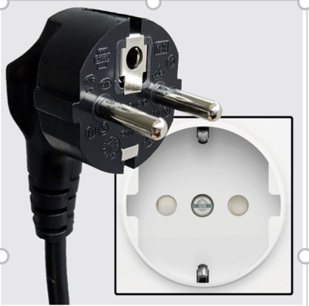

Figure 7 Type F plug compatible with German system

# **Further contact**

Mr. Marko Emersic or Ms. Ling Ling Federhen (Admin)

[Memersic@irena.org](mailto:Memersic@irena.org) ; [lfederhen@irena.org](mailto:lfederhen@irena.org)

Mob: +49 2283 9179 047 (Marko); +49 2283 9179 085 (Ling Ling)

Ms. Hyeonyu Son (LTES Team)

[hson@irena.org](mailto:hson@irena.org); [LTES@irena.org](mailto:LTES@irena.org);

Mob: +49 2283 9179 004

Wishing you safe travel and looking forward to welcoming you in Bonn, Germany.

**Recommended Hotels in Bonn / Nearby**

* Maritim Hotel Bonn — Maritim Hotel Bonn
* Marriott Bonn — Bonn Marriott Hotel
* Ameron Königshof Hotel Bonn — [Ameron Hotel Königshof](https://ameroncollection.com/de/bonn-hotel-koenigshof)
* Steigenberger Grandhotel Petersberg (Königswinter, close to Bonn) — Steigenberger Grandhotel Petersberg
* Hotel Kanzler Bonn — [Hotel Kanzler](https://www.living-hotels.com/hotel-kanzler-bonn/)
* Dorint Hotel Bonn (former Hilton) — [Dorint Hotel Bonn](https://hotel-bonn.dorint.com/de/)
* ACHAT Sternhotel Bonn — ACHAT Sternhotel Bonn
* Günnewig Bristol Hotel — [Hotel Günnewig Bristol](https://www.hotel.de/de/guennewig-bristol/hotel-84062/)
* Motel One Bonn — Motel One Bonn
* Hotel Ibis Bonn (Accor) — Ibis Bonn
* Insel Hotel Bad Godesberg — [Insel Hotel Bad Godesberg](https://www.inselhotel.com/)
* Rheinhotel Dreesen — [Rheinhotel Dreesen](https://rheinhoteldreesen.de/)
* Hotel zum Adler — [Hotel zum Adler](https://hotel-zum-adler.de)
* Hotel Continental Bonn — [Hotel Continental Bonn](http://continental.allbonnhotels.com/de/)